Q. Write about the basic requirements of copyrightability

Ans:

Copyright protects original works of authorship that are fixed in a tangible form of expression, now known or later developed.

* Thus , there are three basic requirements for copyrightability.

1. A work must be original.

2. A work must be fixed in a tangible form of expression.

3. A work must be a work of authorship.

* **A work must be original:**

To be eligible for copyright protection, material must be original, meaning that it must have been independently created and must possess a modicum of creativity.

* **A work must be fixed in a tangible form of expression:**

The copyright act protects works of authorship that are “ fixed in any tangible medium of expressions”. Thus there are two categories of tangible expression in which work can be fixed.

1. copies.

2. phonorecord

* A COPY is a material object (other than a phonorecord) from which a work can be perceived, reproduced, or communicated, either directly by human perception or with the help of machine.
* A PHONORECORD is a material object in which sounds (other than those accompanying a motion picture or other audio-visual work) are fixed and from which the work can be perceived, reproduced, or communicated either directly by human perception or with the help of machine.
* This includes recording in audio cassette or a CD recordings.
* **Works of authorship:**

A copyright act provides that copyright protection subsists in original works of authorship fixed in any tangible medium of expression, now known or hereafter developed, from which they can be perceived, reproduced or otherwise communicated, either directly or with the aid of machine.

Q. With a workflow diagram, explain about the trademark registration process.

Ans:

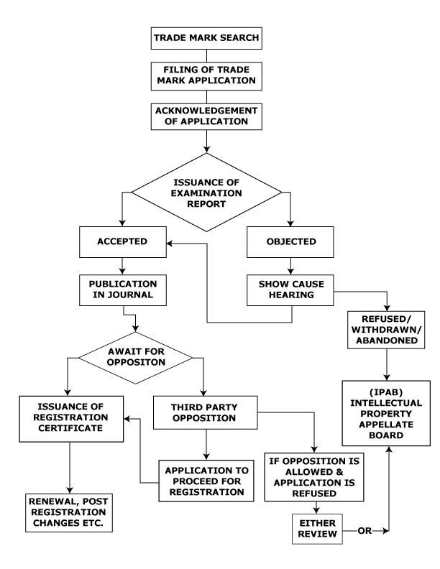

Q. Write about trade secret law.

Ans:

* Trade secrets law is concerned with the protection of technological and commercial information not generally known in the trade against unauthorized commercial use by others.
* The policy basis for trade secret protection is the desire to encourage research and development by providing protection to the originator of business information, and also to maintain proper standards of business ethics.

**Legal base:**

* A relatively recent development in the United States is the adoption of the UTSA, the *Uniform Trade Secrets Act*, which has been adopted by approximately 46 states as the basis for trade secret law.
* Another significant development in U.S. law is the Economic Espionage Act of 1996, which makes the theft or misappropriation of a trade secret a federal crime.
* This law contains two provisions criminalizing two sorts of activity. The first,, criminalizes the theft of trade secrets to benefit foreign powers. The second,, criminalizes their theft for commercial or economic purposes.
* In common law jurisdictions, confidentiality and trade secrets are regarded as an equitable right rather than a property right.

A successful plaintiff is entitled to various forms of judicial relief, including:

* an injunction
* an account of profits or an award of damages
* a declaration